Kundat Srimoola Bhadrakali Temple
Kukloor Village, Virajpet

Table of Contents

Sr. No | Particulars | Page Number
 | Abstract | 3
 | Chapter 1- The Temple | 4
 | Chapter 2- Historical Significance | 6
 | Chapter 3- Role of Oorukaara  3.1 The Priest  3.2 Deva Thakka  3.3 Thirvalakaara  3.4 Okkas and Therige  3.5 Harijana community | 7
 | Chapter 4- Namme Preparation  4.1 Timing and Duration  4.2 Beginning of the rituals  4.2.1 Namme Kuripo and Deva Kettu  4.2.2. Peeli Aat  4.2.3. Pattani  4.2.4. Kombu Urupo and dinner preparation  4.2.5. Bodu Kali | 15
 | Chapter 5- Namme Day 1: Kudhre Namme  5.1 Kudhre Namme  5.2 Bhandara | 21
 | Chapter 6- Namme Day 2: Ballia Namme  6.1 Harijana Bodu Kali  6.2 Ettu Porata  6.3 Theray | 26
 | Chapter 7- Namme Day 3: Choole Namme | 31
 | Chapter 8- Namme Day 4: Wrap-up | 33
 | Conclusion | 34
 | Glossary of Kodava Words | 35
 | Acknowledgements | 40
 | About the Author | 41

Abstract

In the growing age of technology and digitization, recording history has become all the more convenient. The Kundat Srimoola Bhadrakali temple, located in Kukloor, Virajpet, in the district of Kodagu, India is an example of a rich and ancient history gone unrecorded. From the history of the temple, to its transformation and present day practices that occur, the temple has a strong symbolic presence within the village and places afar.
Over the years, there has been a diminishing number of native Kodavas in Kodagu, and a growing disconnect from traditional practices of the land. This receding level of involvement makes preserving traditions and rituals of this small community all the more challenging. With fewer number of residents and senior citizens to pass on this knowledge, several notable, age-old practices are being lost.
This paper is intended to record these very practices and traditions observed at the Kundat Srimoola Bhadrakali temple. In order to carry forward this knowledge and information, a compilation of the oral histories of the residents of Kukloor and one book in particular has been used to write this document. Due acknowledgements are included towards the end of the document.
It should be noted that the writer, being from the Monnanda family himself has laid emphasis on the role and history of the family as compared to the others. This is primarily due to a limitation in access to other noteworthy individuals who may be able to add to this body of work.
This document has been written with the intention of contributing to the existing informal knowledge regarding the Kundat Srimoola Bhadrakali temple, and making this information more accessible, in this day and age, to whoever may be interested in exploring the history and culture of the temple.

CHAPTER 1 – THE TEMPLE

The Kundat Srimoola Bhadrakali Temple is located in Kukloor village of Virajpet Taluk in Kodagu.

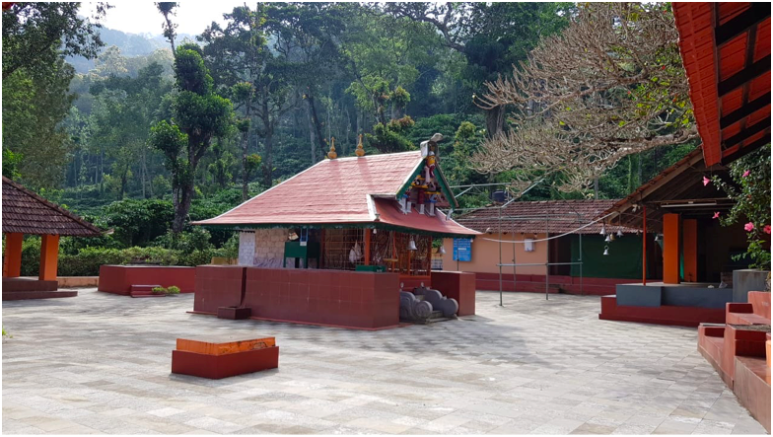
Image 1: Inside view of the temple amidst backdrop of coffee plantation and hills

Location: 12°12'47.1"N 75°48'16.0"E.
Approximately 2 kms from the town of Virajpet, 1 km from Kodava Samaj, Virajpet.

Directions: The closest landmark to the temple is Kodava Samaj, Virajpet. One would follow the road that leads towards Chembebellore from Kodava Samaj and the road to the temple would be on the right, at about a 200 meters distance. There is an arch with the name of the temple etched on it that serves as a landmark at the entrance of this road.

About eight Kodava okkas (families) and 10 Kembati kudis (henceforth referred to as Harijana) come under the temple’s preview. Of the eighty, five okkas: Monnanda, Maletira, Thathanda, Kuttanda and Karnanda are considered native inhabitants of the village with ‘aime-koime’. They are responsible for:
- Offering ‘therige’ during the namme (village festival).
- Managing specific roles and responsibilities in the administration and management of the temple.
- Overseeing the conduct of namme and other celebrations in the village.

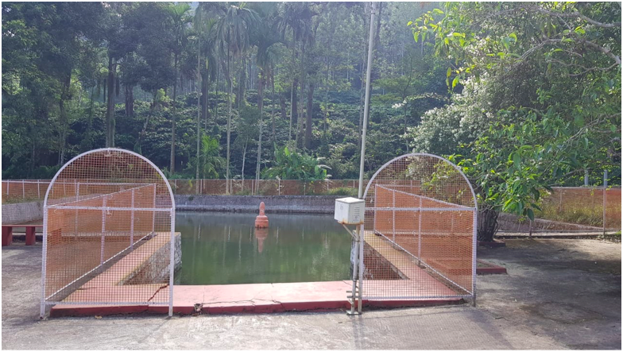
Image 2. Entrance to the tank (kere) where devotees are expected to wash their feet

CHAPTER 2 – HISTORICAL SIGNIFICANCE

Hundreds of years ago, during the Paledhara System (administration system that prevailed before the Haleri dynasty) it is believed that Monnanda, Kuttanda and Thathanda okkas were living on the hills of Kukloor. Legend has it that Goddess Parvathi took the form of Goddess Bhadrakali and came to the earth to kill evil demons who were harassing human beings. She then stood on top of Brahmagiri hills and looked around. Upon seeing the village of Kukloor she was attracted by its nature, the trees, water tank (kere) , the hills and the beauty the land had to offer.
It is then believed that Lord Shiva and Goddess Parvathi appeared in the guise of a Brahmin couple at the Monnanda household as guests. In reverence to the ‘Brahmin couple’ the Monnanda family patriarch gave them gold, silver and a milking cow; And disappeared after leaving the house, shocking the Monnanda family. That very same night, it is said that the oldest man in the family (referred as Monnanda Ajja) had a dream in which Goddess Parvathi appeared and asked him to build a temple in her name with the efforts of the villagers.
The very next morning, a man from the Thathanda family grazing cattle went into a trance (as he was believed to be possessed by the Goddess) and proclaimed that she was Goddess Kali who had appeared in Monnanda Ajja’s dream the previous night. He insisted that the dream was to be taken seriously and asked the Monnanda Ajja to fulfil the wishes of Goddess Kali on those very grounds. This place where the Thathanda man was possessed by the Goddess for the first time is called “Nengotte Kallu”and plays a significant role in the deity’s festival (namme). The possessed man is then said to have run to a place called Nandyanda Kala (the threshing yard for grains) accompanied by the villagers. There he beat the earth with his stick and concluded that place was not suitable to build the temple. He then ran towards a place now called ‘Kudhre Kall’. He found that this place was also not suitable for the temple. He eventually ran to the spot where the temple is now situated and announced to the villagers that it was indeed the right place to build the temple. He also claimed that the goddess wanted to be worshipped as Bhadrakali by the villagers. Hence the people of the village refer to the deity as Bhadrakali or Maathai with utmost devotion and reverence. Monnanda Ajja then sent word to the villagers to assemble in this place and as per directions given by the Thathanda man, they built the temple of Kundat Srimoola Bhadrakali, purely using villagers’ contribution.

During the Lingayat regime (Haleri dynasty), the then king paid a visit to the temple and offered a silver cradle for having been blessed with a baby. He also presented an iron kadathale (sword) to the Harijana deity Aiyappa as a mark of his success in Kodagu. These offerings are still preserved in the temple with an inscription of “LIN” (King Lingaraja) written in Kannada.

CHAPTER 3 – ROLE OF OORUKAARA

3.1 The Priest
Brahmins are said to have migrated from the neighboring district of Dakshina Kannada. At the time, Brahmins were forbidden from practicing agriculture as it involved cutting plants/ trees and were in search for a source of livelihood. As commonly practiced in most temples in Kodagu, the pooje (offering prayer) and other rituals in the temple are conducted by Havyak Brahmins and the same applies in the Kundat Srimoola Bhadrakali Temple.
It is believed that Mathai communicated to the villagers that she wanted to be worshipped in a very particular manner and that she preferred the idol to be a holy stone and rather than an idol made of expensive metals. She wanted flowers and fruits found only in the surrounding jungles to be used for worship. These directions are followed in various rituals to date.
The priests perform various types of pooje through the course of the year. Few of them are noted below:
- Nithya Pooje: as the name suggests this pooje is performed daily at the temple early in the morning. While the priest (henceforth referred to as Patta) performs the pooje and offers ‘naivedya’ (freshly cooked rice with milk and jaggery), it is normal to see the local villagers attend the pooje and start their day with a worship of Maathai.
- Scheduled Pooje: Villagers and other devotees can have pooje performed in the temple as per their requirements. These poojes can be planned and scheduled with the Patta.
- Chowtt Pooje: “Pudiya akki oota “otherwise known as “chowtt pooje” is normally done in the month of February or March after the harvest and processing of paddy (main food crop of Kodagu). The first grains are offered as “naivedya” to the Goddess after a grand pooje and then eaten by the villagers in the form of sweet dish payasa as prasada.
- Chandika Homa: This is performed every year at the time of Navaratri festival as the Goddess is believed to be most powerful during this time. In order to please the Goddess and obtain her blessings, this homa is performed on a grand scale where devotees from Kukloor and other surrounding villages/ towns participate.
- Chouthi: a temple for Lord Ganesha was built recently as part of the many improvement initiatives undertaken in the temple by the villagers. Ganesha Chaturthi (Chouthi) is also celebrated on a grand scale on the auspicious occasion.

3.2 Deva Thakka

As conveyed through the possessed Thathanda ajja, the Monnanda okka was to serve Maathai. This family is called the deva thakka. The oldest male member typically plays this role and in case he is unavailable or sick, any other male member of the okka is to play this role on his behalf.
- The Deva Thakka is accountable for all the decisions made in the management of the affairs of the temple. This includes key decisions regarding the namme, pooje, maintenance etc. of the temple.
- The Deva Thakka chairs all the important meetings of the management council that consists of the villagers, a President, Secretary and Treasurer.
- He administers the vows and conducts the invoking during various rituals in the namme.
Monnanda M Kariappa (Mothi) is the current Deva Thakka of the temple. Kariappa has lived all his life in Kukloor and besides being well versed with all the traditions and rituals is a well-respected man in the village. His father served as Deva Thakka for many years and Kariappa has leveraged the knowledge he acquired from his father. Kariappa’s credentials, knowledge and gentle nature has helped him build a good relationship with the rest of the villagers and under his leadership several initiatives have been successfully implemented, making the temple very popular within the nearby town/ villages.

3.3 Thirvalakaara

Thirvala means getting possessed by gods. It has been a belief for centuries that humans can be possessed by gods and attain certain divine powers during that time. The men who get possessed by gods must observe certain penance and practices. They are respected by the villagers and they help in the smooth conduct of the namme.
As mentioned previously, up until the 1905s or so, Thathanda Kariappa ajja used to be possessed by Maathai and guided the villagers during the namme. However, after his demise, this tradition did not continue. Currently there are three thirvalas and three men from the Harijana community carry out this tradition. It may be noted that this has continued based on kindship or within the same kudi. The three thirvalas; Aiyappa, Mammoodha and Kethamma are continuing this tradition and Aiyappa takes the lead among them and continues to guide the smooth conduct of the namme. Aiyappa wears a red colored panche tied slightly above his knees and is bare chested. He always holds a kadthale. Mammodha and Khethamma wear white kuppiya chaele and hold thoore kol (cane sticks). Aiyappa and Khethamma thirvalas can speak in Malayalam while Mammoodha only communicates using gestures. There are instances when Khethamma Thirvalakaara gets possessed by another deity called Kuliya and during that time he communicates in Kodava thakk. Similarly, Mammoodha thirvalakaara sometimes gets possessed by Ajaappa/Kaarona of the Harijana community and communicates in Kodava thakk. However, the thirvalakaara speaks very few words and most of the answers are indirect and must be interpreted. They have helpers called moopkaara who often help mediate the communication between the villagers and thirvalakaara. Moopkaara serve as assistants to the thirvalakaara and they are also dressed in white kuppiya chaele.

3.4 Okkas and Therige

Five okkas that have originated from Kukloor are considered primary to the temple with specific roles, responsibilities (therige) and privileges.

1)Monnanda:

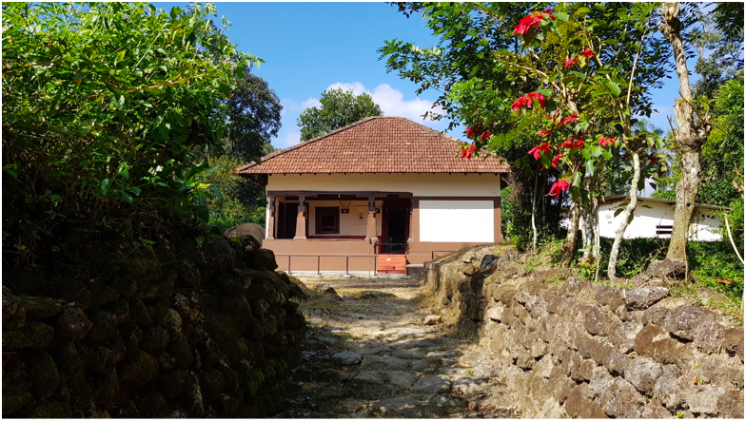
Image 3: View of Monnanda balliamane

Monnanda Okka are the deva thakkas as per Maathai’s wishes and have an important role to play in the affairs of the temple and the namme.. Some of the key roles and responsibilities are highlighted below:
- The oldest male member of this okka is the deva thakka in the temple.
- On the Pattani day of namme (refer to section 4.2) Pattani putt is served to the Harijana men and children in the balliamane of Monnanda family. Pattani putt consists of Kuvale putt (made with ripe jackfruit wrapped in Kuvale leaves) and Chekke curry (curry made of raw jackfruit). It may be recalled that Maathai had insisted on using flowers and fruits found in the nearby jungle and this Pattani putt is made using indigenous ingredients.
- Ballia Namme (main festival) starts from the Monnanda balliamane and all the villagers assemble there (refer to section 4.4).
- In the namme, the kudhare (horse) and choole (prostitute) dance and race in the paddy fields belonging to the Monnanda okka. This is said to be as per the wishes of Maathai.
- On all three days of the namme, a Monnanda man dressed in kuppiya chaele stands at the entrance of the sanctum sanctorum of the temple and oversees the pooje. He also ensures that all devotees get an opportunity to offer their prayers and parike to Maathai and receive the prasada. He is also the custodian of the Bhandara that is offered by the devotees.
- In addition to the namme responsibilities, Puthari festival (inaugural harvest of paddy) is celebrated in the paddy fields of the Monnanda family. All the villagers assemble in the paddy field and the deva thakka harvests the paddy shoots with the ceremonial valaga and firing of a gunshot. The villagers (Kodavas and Harijanas) proceed to the temple amidst bursting of firecrackers and to offer the harvest to the deity. The villagers then harvest at their respective balliamanes.

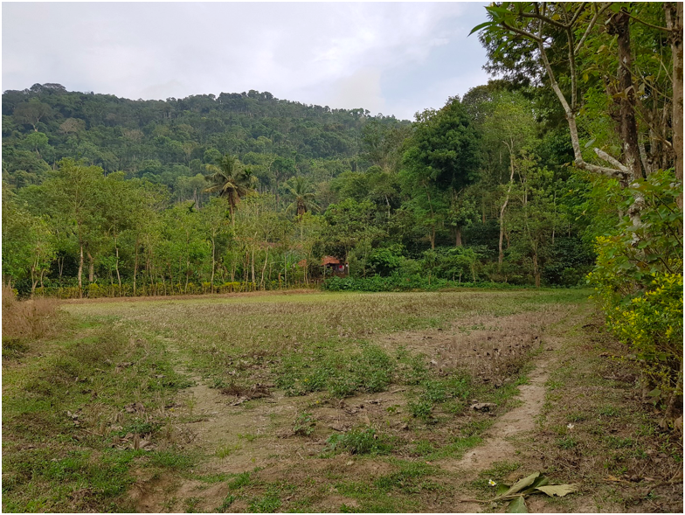
Image 4. Paaryama – Paddy field where the inaugural paddy is harvested on Puthari Day

2)Maletira:

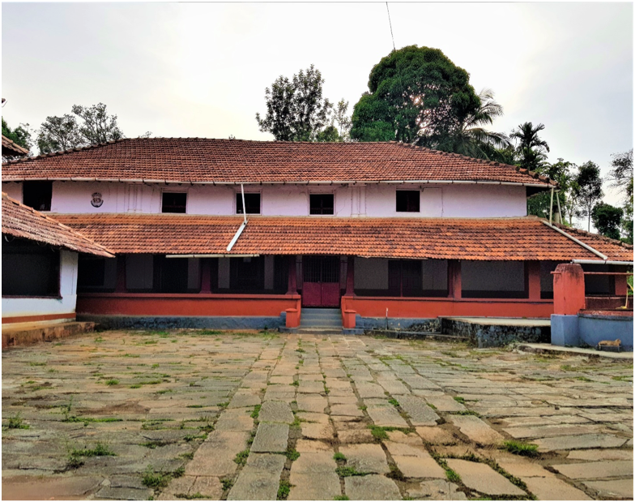
Image 5: View of the Maletira balliamane

Maletira okka is the ooru thakka (village head) of Kukloor village. Their role includes the following:
- The President of the temple committee is usually from this family.
- This okka is the custodian of various artifacts of the temple including the kadthale (symbolic sword used for various rituals), jewels used to decorate the statue of Maathai and bandaara (the offerings devotees give to the temple as a token of their devotion).
- On the days of the namme, the villagers visit the Maletira balliamane at the end of the day to store the kadthale. They are treated to a meal of paputt and koli curry (chicken curry) on the last day of the namme.
- Pattani maatho (end of Pattani) is also done in the Maletira balliamane where the Harijanas are treated to a meal of rice and baale curry (raw plantain curry).

3)Thathanda:

- As detailed previously, an ajja from the Thathanda okka was said to have been possessed by Maathai and was revered by the villagers as a form of Maathai. This tradition continued into the mid 1900’s. However after the demise of Thathanda Kariappa ajja, this tradition ceased and nobody has been possessed by Maathai since.

4) Karnanda:

Karnanda okka played the role of support to the Thathanda ajja who was possessed by Maathai.
- In the past, a man from this okka was responsible for holding the bhasma (holy ash) and giving raw rice (used by the thirvalakaara for various purposes including blessing the people). However, with nobody to succeed Thathanda Kariappa ajja, this has become redundant.
- Karnanda okka is also responsible for maintaining the temple order and cleanliness during the namme; especially after the offerings are made to Maathai on the day of ballianamme (refer to chapter 6).

5) Kuttanda:
- A man from this okka is entrusted with the responsibility of performing the Peeli Aat (a dance form performed in the temple during the namme).
- This okka works with the Monnanda okka during the namme (refer to chapter 6).

While the above 5 are the main okkas with Koime in the temple, there are other okkas that are residents of the village and offer therige to the temple:

Balluda:
- People of this okka are residents of Kukloor village and offer therige in the temple.
- Balluda okka also takes turns along with the five main okkas to help with the Theray Ketto on the ballianamme (refer to chapter 6).

Manduda:
- This okka also resides in Kukloor village and are entitled to offer the therige in the temple. They do not have Koime like the other okkas, but they actively participate in the namme and other activities in the temple.

Nandyanda:
- This okka is now extinct. It is believed that an old woman from this family was last seen in the village around 75-80 years back and her daughters were married to other okkas. There are no other known members from this family after her death.
- Nandyanda okka has to offer a kudhre (horse), ettu porata (coconut loaded on bullock) and choole (prostitute).
- Their responsibilities have now been taken over by members of the Maletira okka.
- The kala (threshing yard) that belongs to the okka is called Nandyanda Kala. This is a sacred place and is of great significance in various rituals of the namme.

3.5 Harijana community

As most villages in Kodagu, different castes lived in harmony and have co-existed for centuries. The Harijana community in Kukloor play a significant role in the affairs of the temple, none more important than the namme. The kudis of this community were associated with the Kodava okkas and they worked for the Kodava families helping them in their paddy fields, coffee estates, managing their cattle etc. Initially they were given paddy and hay for their work but now they are paid money. However, with the changes in their socio- economic status has opened them up to other lucrative job opportunities. Most of the members of this community are working in the nearby town of Virajpet and some running their own business. However, it is heartening that they are as closely involved in the temple and namme as ever. Some of their roles and responsibilities are:
- Playing the Vaalaga (traditional music), an important part of every Kodava ritual is played by this community.
- It is the members of this community who are possessed by gods (thirvalakaara) and guide the conduct of the namme. One of the members is possessed by Lord Aiyappa, who with the help of two other gods Mammoodha and Khethamma ensure that the namme is conducted as per the traditions and guide the villagers.
- The Pattani (start of the namme) commences with the Harijana community offering a fowl at their ambala (where the holy shrine is located) early in the morning, and have a meal of rice and chicken curry. Their Pattani lasts for 2 days with the Pattani Maatho meal of rice and jackfruit curry in the balliamane of the Maletira family.
Every Harijana family is required to bring a chicken on one of the days of the namme to be hurled from one side of the temple (place where the Harijana deities are worshipped) to the main temple. This will be further described in the section on namme (Chapter 6).

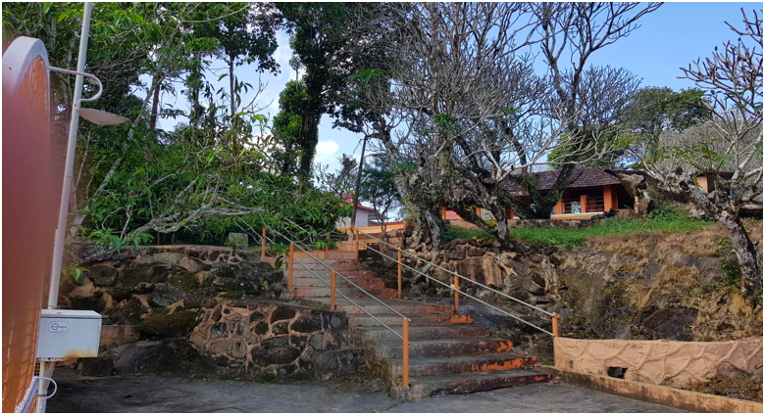
Image 6. View of the temple from the tank

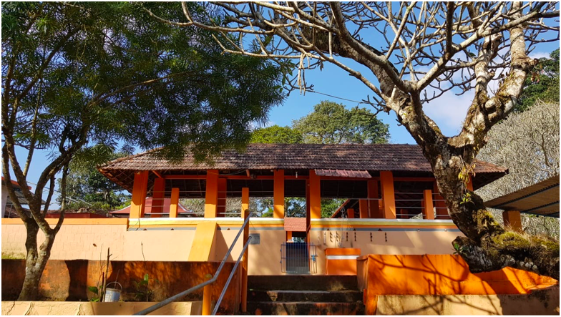
Image 7. Entrance to the temple with a view of the Harijana deities

CHAPTER 4 – NAMME PREPARATION

Kundat Bhadrakali Namme is the most important event in the temple and the most auspicious occasion for the entire village. Although it has tremendous religious and traditional significance, it is also a social occasion that the entire village community looks forward to. Like most village festivals, it runs over several days and brings the entire village together promoting unity and a sense of community among all the villagers irrespective of caste or creed. This is a time when villagers residing outside of Kukloor and women of Kukloor married outside the village, visit the village and take part in the festivities. It is common to see people native Kukloor residing outside the village (some outside Kodagu, the state or even country) plan their vacation to take part in the namme. Friendships are made and old acquaintances renewed during this time by taking part in the rituals together or socializing over dinner/ informal get-together. The tradition has continued for generations and the mood of the village is of joy, friendship and celebrations.

4.1 Timing and Duration

Namme in Kundat Bhadrakali temple is typically celebrated around the third week of May and lasts several days. The main festival lasts three days and is typically from the third Saturday through Monday of May. However, there have been exceptions when it happens from the third Monday through Wednesday. The preparations of the namme begin several days prior to the main days as is explained further.

4.2 Beginning of the rituals

4.2.1 Namme Kuripo and Deva Kettu

The start of the namme is called Namme Kuripo which means ‘start of the festivities. It is on the first day of the month of Kaadiyaar (around mid-May) according to the Kodava calendar. The namme starts with the villagers gathering at the kere (tank) near the temple while the priest performing pooje to the goddess. The Deva Thakka administers the vows of the festival to the villagers. The thiruvalakaara (men belonging to the Harijana community who are possessed by gods) direct how the festival is to be conducted. Now there are three men who get possessed by the deities Aiyappa, Mammoodha and Khethamma. Aiyappa takes lead in ensuring the namme is conducted as per the established traditions and the right level of discipline is maintained. The roles and responsibilities of each okka and Harijana kudi is already established and any alterations may be done only under special circumstances.
There is also a ritual called tappadaka at which all the villagers take a vow to observe certain kettu (restriction) including dietary restrictions which are broken during the main festival days. Some of the restrictions include refraining from harming animals, cutting trees/plants, leading a life of austere and refraining from non-vegetarian food and alcohol. The villagers are expected to not leave the village for overnight stay. No weddings or other auspicious events are held during this period and funerals are conducted in a subtle manner without the customary valaga or firing of the gunshots. Corpses are usually buried instead of being cremated during this period. Violators of these restrictions are required to pay a small price called Thappu Pana (monetary penalty for the mistake). The amount varies depending on the social and economic position of the offender.

4.2.2. Peeli Aat

After namme kuripo, the villagers spend days leading up to the main festival performing various rituals and preparing for the namme. The roads leading up to the temple are spruced up by de-weeding the ground and removing pebbles along the paths leading up to the temple. The temple premis is given a makeover in preparation for the namme.
Peeli Aat, a traditional dance is performed by a male member of the Kuttanda okka (the okka is split into two and one of the parts of this okka holds this responsibility). Peeli Aat is performed 101 times around a stone called Peeli Kall located outside the main temple gate. The dancer holds a bunch of peacock feathers and is dressed in a white kuppiya. The meda (Harijan man who plays a drum) and four Kodava men play the dhol (drum) while singing the Bhadrakali song. This dance is usually performed for 1, 3, 5 or 7 days (odd numbers only), with the last day being the day before the Pattani.

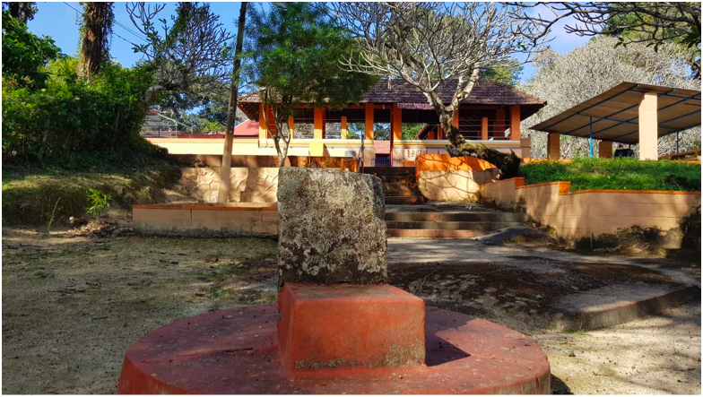
Image 8. Peeli Kall around which the Peeli Aat is performed

4.2.3. Pattani

The day before the Kudare (first day of the main namme) is called Pattani. The day starts with members of the Harijana community meeting at their ambala (holy shrine located near their colony) and each kudi offers a fowl to the gods. This ceremony happens at dawn after which they have a meal of rice and curry made with the fowls that are offered to the deity. Post the early morning meal, they are not supposed to eat anything during the day. The Kodavas too, are not supposed to eat anything during the day. However it is not uncommon to find people refraining from rice or rice-based items but eating other grains and vegetables. The villagers get together to clean the area surrounding the temple while the path up to the temple is decorated with thorana (symbolic of most hindu festivities). Villagers perform a pooje called Naga Pooje at the Nagasthana which is near the tank belonging to the Maletira okka. This tank is located about half a kilometer from the temple near the Maletira balliamane.

Pattani Putt: Kuvale Putt (snack made with the extract of ripe jackfruit and mixed with coarsely ground rice and steamed in a leaf called Kuvale leaf) is a symbolic snack made during the namme.. Each family in Kukloor prepares Kuvale Putt during the namme. In the afternoon, male members and children of the Harijana community who have been fasting since their early morning meal, proceed to the balliamane of the Monnanda okka. There they are served Kuvale Putt with Chekke curry.

4.2.4. Kombu Urupo and dinner preparation

Kombu (horn) is a very important instrument for Kodavas. Besides being an integral part of the valaga, it has been used as a means of communication for ages. On the day of Pattani, the men of the village (oorkaara, which includes Kodavas and Harijanas) gather at Adhisthana or Nengotte Kall (location where the Thathanda ajja was first possessed by Maathai) at around 8 pm. Valaga kaara (Harijana troop playing the valaga) blow the kombu which is considered the signal for all the Kodava women in the village to start making dinner. This process is of essentially making rice that they were forbidden from eating all day. This does not apply to the Harijana women as their Pattani lasts two days (explained in the subsequent section).
While the women start making dinner upon hearing the kombu the men and male children assemble at Nengotte Kall. This is where the details of schedule and activities of the namme are finalized. It may be noted that while the rituals and customs of the namme are already in place, the exact time, subtle responsibilities etc. vary and are finalized on the day of the Pattani at Nengote Kall.
The priest starts the rituals with a pooje to Maathai and four Kodava men sing the Bhardrakali song beating the drums. The Thirvalakaaras get possessed and give specific instructions to the villagers on how the namme must be conducted. Since Thathanda ajja getting possessed by Maathai has stopped, the man who gets possessed by Lord Aiyappa is considered the lead among the Thirvalas. Thirvalakaaras communicate with the villagers if they see any concerns or issues in the village, or the way in which the rituals have been carried out so far. The villagers revere the Thirvala and adhere to their instructions.
While most of the customs and rituals remain the same every year, there may be subtle modifications and the Thirvalakaaras communicate these subtleties. The men/boys who will carry the Kudhare or dress up like choole are decided at this gathering and the Thirvalakaaras bless them with grains of rice. They are expected to refrain from eating non-vegetarian food and rice on the respective days of the namme. The whole convoy then proceeds to Nandyanda kala while the Bhadrakali song sung by Kodava men and the valaga. The Thirvalas lead these rituals and the villagers follow their directions. Maathai is invoked at Nandyanda kala and the details of the plan for the Bodu Kali (dressing up in different costumes and dancing seeking gifts and money) is decided. The villagers then disperse to their homes with a set plan to assemble back at Nandyanda kala for the Bodu Kali later that night.

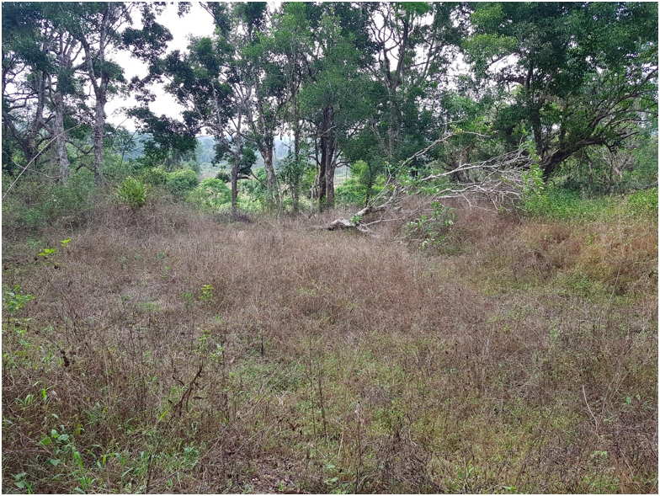
Image 9. Nandyanda Kala – a significant place in the namme

4.2.5. Bodu Kali

The Pattani fast is broken and the villagers have dinner. Rice is a mandatory dish for dinner that night. The mood in the village is very festive by then and it is common for friends and cousins to get together for a drink at dinner. After dinner, the male members irrespective of age dress up in various costumes. The most common themes are as dressing up as vadda and thimmi (laborers who work in the paddy fields or help dig the earth), Muslim traders from Kerala, sanyasi (sage), women, etc. They assemble at Nandyanda kala at a pre-decided time (usually around 10 PM). Four men play the drum singing songs (batte paat, thaali paat etc.) and it is the Thirvalakaras who lead the way. The men and boys dressed in costumes are in a joyous mood and dance to the songs of the men playing the dhol and the Valaga. The procession makes its way to the temple and dances outside the temple. Nobody enters the temple at that time but the kalikaara (men dressed in costumes) dance for the goddess near the platform where the Harijana deities are kept. Thirvalakaaras lead the dance and the Kalikaaras dance as per their wishes. Symbolically this depicts Kalikaara performing for Maathai in the temple after which they perform for the rest of the villagers.
The possession of the Thirvalakaaras cease and the entire troop proceed to each of the balliamanes of all the okkas starting with the Ooru thakka (Maletira) balliamane. The men playing the dhol sing the Batte Paat as they approach the balliamane. Batte Paat means song of the path. The singers sing about the path to the balliamane, they describe the ooni (narrow passage that leads to the yard of the balliamane), the work done to decorate it, the yard and how well it has been prepared for the namme, the steps to the balliamane and finally the glory of the balliamane. They sing about the verandah, the hall, the lamp in the main hall and wish well for the okkas. The members of the okka including women and children are excited and happy to welcome the kalikaara and look forward to the funny costumes and their acts. The kalikaara then dance while the men playing the dhol sing the Thaali Paat describing the kalikaara and their costumes in a funny way. Some kalikaara put up silly acts or enact hilarious scenes from movies to entertain the members of the okka. The kalikaara and the rest of the troop are given money for their performance signifying the concept of bodu (seeking alms) and are also treated with coffee and snacks (Kuvale Putt being a staple snack). It is common to have alcoholic beverages served which helps keep the spirits of the troop high. The men who play the dhol (called dholkaara) sit in the main hall and sing about the men of the host okka glorifying the okka and its men starting from the moolapurusha or Kaarona to the current generation. All the members of the okka gathered there, including the visiting daughters of the okka married to other families, offer their token of appreciation by contributing money that is collected for the dholkaara. After enjoying the hospitality and entertaining the members of the Maletira okka the troop proceeds to the next okka:Karnanda.
Karnanda okka has two parts (called bhaaga). Every year the Bodu Kali visits the balliamane and the house belonging to one of the bhaagas. Members of the bhaaga that are not visited that particular year assemble at the balliamane of the other bhaaga and take part in the namme. The process of performing, entertaining, collecting money and other goodies is repeated here and the troop then proceeds to the Thathanda balliamane. Kombu is an integral part of the entourage and its noise serves as an alarm for the women and children to wake up and get ready to receive the troop as it often well past midnight when they arrive. Following the Thathanda balliamane, the troop proceeds to Monnanda balliamane followed by the two balliamanes of the Kuttanda okka. Kuttanda okka has two bhaagas and hence two balliamanes. By the time the kalikaara finish performing at the last Kuttanda balliamane it is almost dawn. After visiting all the balliamanes the troop proceeds to Pattamaada (residence of the Brahmin priest) and collects money from the priests after performing for them. The bodu kali culminates at the Nandyanda Kala, and everyone makes a small contribution from their collection as bhandaara (money collected for the temple which is used for the maintenance and betterment of the temple). The exhausted Kalikaara proceed to their homes to get some well-deserved rest.

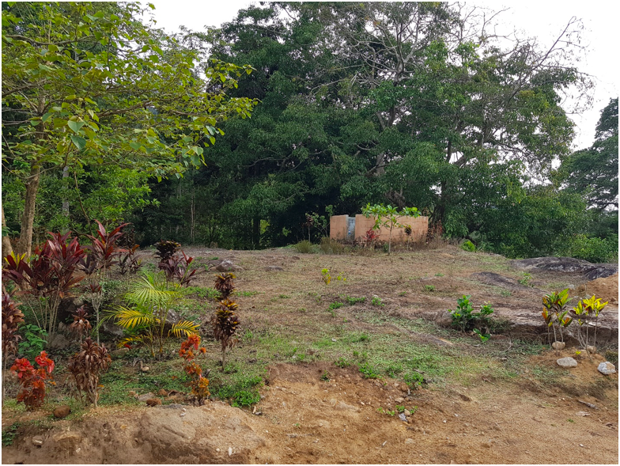Image 10. Adhisthana where Thathanda ajja got possessed for the first time

CHAPTER 5 – NAMME DAY 1: KUDHRE NAMME

5.1 Kudhre Namme

The day after Pattani is the first day of the main namme. The pooje starts that morning. The team of priests who perform the pooje are augmented by an extended team from other temples to manage the workload. Chande is a set of drums played during the pooje and a team of drummers from Kerala are summoned for the same. The sound of chande and bells rung during the pooje fill the entire village with an atmosphere of devotion. Visitors from the village and nearby towns/ villages flock to the temple to offer prayers and have pooje performed in the name of their family members. The deity is decorated with special sarees, jewels and flowers called alankaara (decoration). Deva Thakka or a male member of the Monnanda okka is always present in the temple during the day to oversee the pooje.
The Nandyanda, Maletira and Monnanda okkas are required to make offerings of a Kudhre (hollow horse without legs made with braided split bamboo). The horse back has an opening large enough to allow a man’s head and shoulders to pass through. The frame of the horse is decorated with simple plain cloth that is usually shade of red. The long neck is draped with a chaele (the waistband that is worn by Kodava men as their traditional costume). Being consistent with using natural resources, the eyes, ear, tongue and tail of the horse are made with the bark of areca nut tree and it is colored using natural ingredients like turmeric and lime (mixing turmeric and lime makes red color). As mentioned previously, the Nandyanda okka is extinct and their responsibilities are fulfilled by members of the Maletira okka.
Though the pooje lasts all day, the namme on this day starts only around mid-afternoon. The decorated kudhre offered by the Maletira okka must be carried by a male member of the Thathanda okka or any man designated by that okka. The members of the Maletira and Thathanda okka assemble in the former’s balliamane and so do the Thirvalakaara and Kombukaara (the two men belonging to the Harijana community playing the kombu) along with the meda who plays a drum called parey. The Thirvalakaara get possessed and instruct the time when the kudhre must be lifted. This person should have followed certain restrictions like refraining from eating meat and had a bath prior to the namme in order to carry the kudhre. He wears a pair of shorts and a long-sleeved white shirt and mande thuni (traditional Kodava turban that is hand wrapped). Once the kudhre is mounted on him and is tied around his neck, he wears a white kuppiya (traditional knee length Kodava coat), the bottom of which is spread on the body of the kudhre. He then dances inside the main hall of the balliamane as four men play the small drums called dhudi and sing a song. The kudhre then dances in the yard of the balliamane and the Thirvalakaara take turns to dance along. The dhudi and song continues along with the kombu beginning the festivities. The Thirvalakaara bless the members of the okka especially those who are old or weak and unable to make it to the temple for namme.
The troop led by the Thirvalakaara invokes Maathai and then proceeds towards the Monnanda balliamane. A young maiden will carry the thaliyathakki bolcha (brass plate with rice grains and a small lit oil lamp). This is an important part of the ritual and the young girl leads the procession as they proceed towards the temple. The constant blowing of the kombu is an indicator to the Monnanda and Kuttanda okkas to gather at the former’s balliamane. As the troop reaches close to the Monnanda balliamane the Maletira kudhre stays back at the paddy field belonging to the Monnanda okka while the rest of the villagers and Thirvalakaara proceed to the Monnanda balliamane. The same ritual is repeated in the Monnanda balliamane with a man from or designated by the Kuttanda okka responsible to carry the Monnanda kudhre. The troop leaves the Monnanda balliamane after invoking Maathai while the Maletira kudhre waiting in the paddy field joins them and together they proceed to Nandyanda Kala. The kudhre offered by Nandyanda okka (decorated and carried by a part of the Maletira okka) waits for the Thirvalakaara and the villagers.
The dance and previously described rituals are conducted at Nandyanda kala. The three kudhres led by the Thirvalakaara walk towards Pattamaada (residence of the Brahmin priest) and then to a holy stone called Nengotte Kall. There the kudhre climbs the holy stone, spins three times and worships Maathai. The villagers then invoke the deity and proceed towards the paddy fields belonging to the Monnanda okka. Here the three kudhres run a race accompanied by the Thirvalakaara from one field to another (a distance of about hundred meters). It is believed that Maathai had instructed that she wanted the kudhre to run and dance in the paddy fields of the Monnanda family. It may be recalled that during Puthari, paddy that is offered in the temple is also harvested in this field. The rest of the villagers along with the valaga will be patiently waiting at this paddy field. The kudhres dance as the four men playing the dhudi sing and the valaga joins playing the song. The Thirvalakaara dance along and it is not uncommon to see them dance for longer periods of time. The procession then proceeds towards the temple after invoking Maathai.

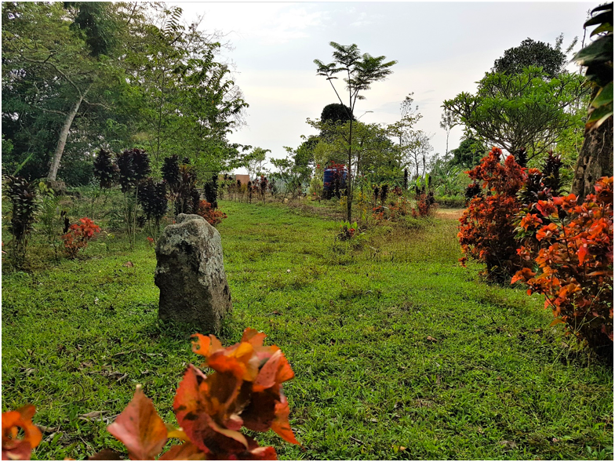
Image 11. Kudhre Kall that the Kudhre and Choole climb up and spin three times

The Thirvalakaara lead the way and run back and forth between the temple and the procession in their state of possession. The valaga is playing and the villagers beat the dhudi giving the entire scene a festive atmosphere. Upon reaching the temple, the kudhres and the rest of the troop are blessed by the priest with the sprinkling of the holy water. The kudhre then repeat the dance in front of the platform where the Harijana deities are kept. Once the Thirvalakaara gives the permission, the villagers along with the kudhre enter the temple. The troop then take three rounds of the temple, after which the kudhre dances twice again: once in front of the shrine for the botekaara aiyappa (hunter) and then in front of the main temple. The Kodava men and boys perform the Bolkaat (a traditional form of dance) holding small swords called kadthale around a stone platform by the side of the main temple. Four men play the dhudi and sing the Baalo Paat (a traditional song sung for the rhythmic beat of the dhudi). This song is about the glorification of the Sun, Moon and Earth and singing in praise of the gods and goddesses. The kudhres walk around the stone three times before the frame may be lifted off the men, and they can finally rest.
Once the Bolkaat is performed, prasada (a dish made of parched rice mixed with jaggery and grated coconut) is distributed to everyone. A kind of coffee called Panaka (coffee mixed with black pepper) is also served to the villagers. The Brahmin priests prepare these and the Kodava villagers take responsibility to distribute it amongst everyone.
The Harijana community perform a ritual in front of the platform where their deities are kept. They use dry bamboo stems and dry hay to light up a fire and sing a song around it, while playing the dhol. This ritual is to commemorate the slaying of a wicked demon by Maathai on this day. The Harijana men then start dancing to the tune of valaga and throw into the air about twenty-five chicks which perch on the roof of the temple compound. The Kodava villagers and guests who are on the other side of the roof must try to catch the chicks and are allowed to take home their catch. The Harijana kudis work for the Kodava okkas and receive paddy, hay and money for their services and the birds they offer is considered a gift from their side to the Kodavas. The Kodavas on the other hand consider it a symbol of good luck to be able to catch one of these birds. They take it home and care for it. This ritual highlights the inter-caste solidarity that has been prevalent for centuries. The women, children and guests disperse from the temple while the oorukaara (villagers) stay back to ensure the temple premises are cleaned in addition to taking care of few other activities.

5.2 Bhandara

Devotees express their gratitude and devotion to Maathai in many ways and Bhandara is one of them. While Maathai is supposed to have insisted on keeping money and material wealth away from her worship and hence no donation is sought, the devotes have been generously offering money to the temple for many years now. Kundat Bhadrakali temple collects more amount in Bhandara compared to most temples around the area even though the village of Kukloor is much smaller in size compared to surrounding villages. Besides Bhandara, the devotees offer other items to the deity such as jewels (mostly made of gold), sarees, kadthale etc. It is a common practice for devotees to pledge to offer a miniature silver replica of a human body part if they or their family member is suffering from an ailment pertaining to that body part. This is often offered at the namme as a token of gratitude if the person is cured of that ailment. An idol offering of a replica of a child is also common if the devotee is planning to have a child. The Bhandara money is used for the upkeep and maintenance of the temple and also to carry out development activities in and arounf the temple.
At the end of the day’s namme, the villagers open the box where the Bhandara is collected and count it to ensure the account is maintained correctly. Once this is done, the oorukaara proceed to the balliamane of the Maletira okka carrying the dhudi and the kadthale used for the Bolkaat. This is where they are stored as the Maletira okka is the custodian of these artifacts. The oorukaara then return to their homes.
While the Kodavas observe Pattani for one day, the Harijana community have two days of Pattani and are hence refraining from food (now interpreted as cooked rice) on this day as well. In the evening they proceed to the balliamane of the Maletira okka where they are served a meal of rice and curry made of plantain. This is called Pattani Maatho (ending the Pattani), marking the end of the day’s festivities.

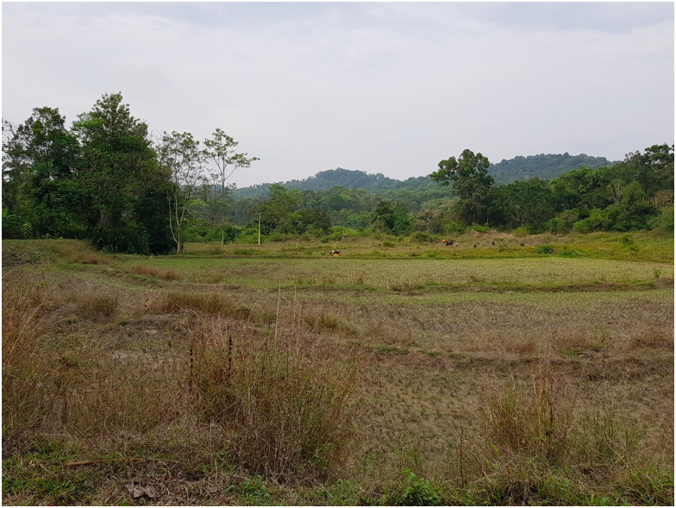
Image 12. Paddy fields where the Kudhre and Choole run the race

CHAPTER 6 – NAMME DAY 2: BALLIA NAMME

The Main festival: Ballia Namme

Day 2 is the ballia namme or the main festival and typically falls on a Sunday. This helps people from nearby villages and towns to participate in the festivities. The day has three main events culminating in the Theray (Naalandehere) at night when the main pooje and offering is made.

6.1 Harijana Bodu Kali

This is the first event of the day. The Harijana community accompanies the Kodava men and boys on their bodu kali, however they do not dress-up or get money that night. On the morning of the ballia namme the men and boys of the Harijana community dress up in various costumes and assemble in their ambala (holy shrine). It is common to find them dressed up as women, famous personalities, or paint their bodies like tigers and bears. Some even smear themselves with slush (called bund kali) or cover themselves with bundles of hay. They are accompanied by the valaga and four men playing the dhol singing various songs such as the Bhadrakali song, batte paat, thaali paat and manepaat. The carnival proceeds to the temple where they dance in front of the platform where their deities are placed. This is a symbolic performance for the deities. They then follow the same path as their kodava counterparts (explained earlier) and go from one balliamane to another starting with the Maletira balliamane culminating in the Kuttanda balliamane. They receive money from the kKodavas highlighting the concept of bodu (seeking alms).

6.2 Ettu Porata (Ettu meaning ‘bull’, and Porata meaning ‘carry’)

As was described in the paragraph on Kudhre Namme (Chapter 5.1), the namme in the afternoon starts at Maletira balliamane and the Thirvalakaara along with four men playing the dhudi accompany the ettu (bull). The ettu is arranged by the Maletira family. A jute bag filled with coconuts is loaded on the bull. Each family in the okka is required to contribute a certain number of coconuts as therige (absolute meaning of the word is tax but, in this context, it is an offering).
The procession arrives at the Monnanda paddy field where the bull stays back while Thirvalakaara along with the men playing the dhudi proceeds to the Monnanda balliamane. On their way the Thirvalakaara visits the Kuttanda balliamane and blesses them. The Monnanda okka also arranges a bull and the bag of coconut is loaded on its back. The procession then proceeds to the paddy field and joins the rest of the villagers and the bulls. Thathanda family is also required to arrange a bull laden with coconuts and joins the procession in the paddy field. Valaga and people dancing to its beat begins the festivities of the day.
Upon invoking Maathai, the procession led by the Thirvalakaara proceeds to the temple amidst the sing- song of the valaga and the dhudi. Upon reaching the entrance of the temple the priest blesses the troop by sprinkling holy water. The procession is led by maidens carrying the thaliyathakki bolcha followed by the men playing the dhudi who in turn are followed by the bulls and the rest of the villagers. The troop takes three rounds of the temple offering prayers to Mathai. The priest blesses the bull and offers it garlands. It is considered auspicious and good fortune to have your bull take part in the ettu porata. The bags of coconuts are unloaded from the bulls and they are set free to go back home. As on the day of the Kudhre Namme, the villagers then perform the Bolkaat holding Kadathale for the Baalo Paat sung by four men. The devotees are treated to prasada and panaka after which they return to their homes.

6.3 Theray

This is considered the ‘main’ event of the namme and involves a community called Panika who perform the rituals as detailed later in this section. Each of the five okkas along with the Balluda okka is responsible for arranging the Theray and taking responsibility on a rotational basis. Balluda okka is not in the list of five okkas but this is a part of their Therige to the village and the temple. Panikas do not live in Kukloor but arrive on this day to perform the festivities. They arrive at the Monnanda balliamane late afternoon and start the preparations. With a brass mask of Maathai as the center, the Panika builds a circular Theray which is a framework of bamboo covered with thin sheets of the pith of a plant called Pambale.
The villagers assemble at the Monnanda balliamane at about 8 PM after dinner and as per Maathai’s wishes, the festivities start from here. The celebrations begin with invoking Maathai and the Panikas singing a song in Malayalam about the glory of Maathai. The villagers along with the Panikas carrying the Theray, proceed to Nandyanda kala. As is the case with most events, the procession is led by the Thalithakki bolcha; The only difference being that now it is carried by a man and not by a maiden. Women are forbidden from going to Nandyanda kala and they participate at the Theray in the temple. At the Nandyanda kala, the Panika places the Theray leaning against a tree called the Devakalli tree, and worships it. A fire is lit in the center of the kala followed by the valaga troop playing while men and boys dance to its beat. The Panika offers a fowl and the villagers clean it and it is roasted in the bonfire that is lit. A piece of the cooked meat and some alcohol is offered to the Theray and the rest is consumed by the villagers as prasada. The goat to be sacrificed as an offering to Maathai is also brought here.
The Panika who is supposed to carry the Theray gets ready for his performance. He wears tiny bells called gaggara around his ankles and smears paint on his face. He wears a turban on his head and a bamboo frame covered with a bright colored cloth around his waist. The performance begins after the Thirvalakara who are already possessed by the gods arrive at Nandyanda Kala. They inspect the Theray and ensure that all arrangements are in order. The Thirvalakaara of Aiyappa takes the lead and indicates the appropriate time for the Theray to be placed on the Panika’s head. Meanwhile the Thirvalakaara who is possessed by Mammoodha writhes on the ground and rolls around the yard. It is believed that he goes temporarily blind while doing that. The Thirvalakaara of Aiyappa has the power to bring back Mammodha’s eyesight and have him back up on his feet. The Panika, carrying the Theray performs a dance to the song and beat of the drum of his counterpart. The Thirvalakaaras take turns to make the Panika dance in front of them. The oorukaara witness these events with devotion.
The group of people, led by the Thirvalakaara followed by the man carrying Thaliyathakki bolcha accompanied by the Panika with the Theray on his head and the rest of the oorukaara. proceed to the temple. Along the way they stop at the holy location of Nengotte Kall to offer prayers and invoke Mathai. The villagers dance to the beat of the valaga and four men play the dhol singing the Bhadrakali song making it a very boisterous environment. As they approach the temple, the Thirvalakaara run back and forth from the temple and the procession. Meanwhile, the women and children who are not allowed to go to Nandyanda kala have assembled at the temple to receive the procession and seek blessings.
Once the procession reaches the yard of the temple where the Harijana deities are kept, the priest comes out of the temple and sprinkles holy water on the Panika and the rest of the oorukaara. The Thirvalakaara who is possessed by Aiyappa takes two swords kept on the platform, places one on his head and hits it with the other. This is done amidst the valaga playing the appropriate beat and villagers dancing. After he hits the sword a few times, his head starts bleeding and blood drips over his face, but he is alive. This ritual is called Narahuti (human sacrifice). Then the Panika carrying the Theray dances while his counterpart sings a Malayalam song in glory of Maathai. The Thirvalakaara take turns and dance in front of the Panika. While dancing, the Panika holds a small sword in his hand and oorukaara keep a few lit wicks on the sword. The Panika dances till all the wicks drop from the sword. It is common for the Thirvalakaara to make the Panika dance and he can stop only when they give their consent. The Mammoodha Thirvalakaara dances to the beat of the valaga with the sacrificial goat. He gives the impression that he likes to play around with the animal and has fun with the animal (indicated by his smiles). The procession including the Panika can proceed inside the temple only after the Thirvalakaara have given their permission. A sack of coconuts that are collected from each of the okka during the ettu porata is kept on the verandah of the temple and before the procession enters the temple, the villagers hurl it against the steps breaking them into small pieces. Each and every coconut has to be broken, and it results in a huge pile of coconut pieces scattered at the steps of the temple entrance. This is called eed kaai. The Harijana children collect these pieces as prasada to take home.
The Panika carrying the Theray and the oorukaara go around the temple three times and the Panika repeats his dance twice; once in front of Maathaai’s statue and then in front of the shrine dedicated to botekaara Aiyappa. Meanwhile, the Thirvalakaara continue to be possessed. The villagers approach them asking for advice regarding personal issues they are facing, health, children, business etc. The Thirvalakaara are believed to be the voice of god and can guide them with potential solutions.
Once these rituals are completed, the women, children and guests leave the temple and proceed home. The Brahmin priests also lock the temple and proceed to their residence. It is well past midnight by now and is time to sacrifice the animals dedicated to Maathai. The Panika who is responsible to conduct the sacrifice makes a small incision on one of his fingers before decapitating the animals. It is expected that he offers a few drops of his blood before the animals are offered. The ooru aad is offered first. The goat is taken around the temple three times with the chanting of ‘aalalla amme aad’ meaning it is not a man but a goat. Myth is that several thousand years ago, a human being was sacrificed to the deity but now a goat (aad) is offered instead, hence the chanting. After the animal is offered, the villagers turn their backs on the scene of the offering and remain silent for a few minutes. This is to allow the dhoothas (body guards) of the deity to consume the essence of the sacrificed animals in peace. Then the ooru koli (village fowls) are offered in the yard outside the temple close to where Harijana deities are kept. Again, the villagers turn their backs on the scene of the offering. Before departing to their homes, the villagers tie the headless carcass of the goat to a tree (deva kalli mara or oleander tree) outside the temple compound near the kere (tank). The carcass remains hung on the tree for more than 48 hours before it is taken down and cooked for the villagers. It is to be noted that no birds such as vultures or kites touch the carcass, nor does the flesh go bad despite the heat of the summer.
Several years ago, tens of goats and even sheep were offered on this day. However, Maathai communicated through Thirvalakaara, insisted that the number of animals sacrificed should be reduced. Since then only one goat is offered. Devotees who are interested in offering goats to the deity can contribute in the form of money. Devotees offer fowls as offerings that are capacitated by the Panika and the birds are taken home by the devotees. The okka that is responsible for the arrangement of the Theray are also expected to offer a fowl.

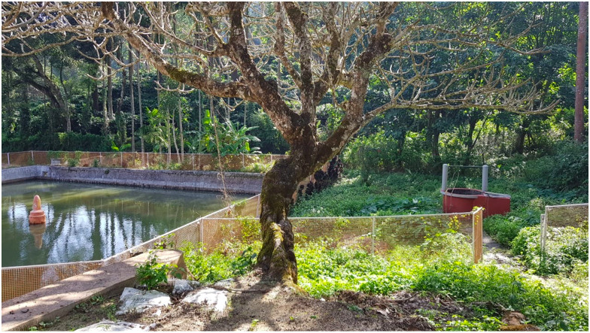
Image 13. Tree by the Kere (tank) where the carcass of the goat is hung

CHAPTER 7 – NAMME DAY 3: CHOOLE NAMME

On the third day of the namme, men belonging to the Karnanda okka are responsible to clean the temple and remove all the blood stains. The Brahmin priest then purifies the temple spraying consecrated water and uttering the appropriate mantras. This is completed before the pooje starts in the temple and the devotees start arriving.

Choole Namme

Choole means prostitute. A young boy around 10-15 years old is dressed up like a woman with saree, jewels and make-up as a choole. Like the kudhre, choole is also a symbolic offering made to Maathai and sometimes ‘votive’. For instance, when a boy is ill, his parents make a vow that they will dress him up as choole at the coming namme.
Most of the rituals are similar to that of kudhre namee. The okkas of Monnanda, Maletira and Nandyanda are supposed to make the offering of choole and are assisted by Kuttanda, Thathanda and Maletira okkas respectively. The namme starts around mid-afternoon in the balliamane of the Maletira okka where the choole offered by Maletira okka, dressed up by a boy belonging to or designated by the Thathanda okka is ready. The Thirvalakaara lead the namme by having the choole dance to a song sung by four men playing the dhudi. The choole dances first inside the main hall of the balliamane, and then in the yard. The procession is led by a maiden holding Thaliyathakki bolcha and followed by the Thirvalakaara accompanied by the men playing the dhudi, kombukaara, drummer and choole. The groups proceed to the paddy fields of the Monnanda okka. The choole waits in the paddy fields while the rest of the procession proceed to the Monnanda balliamane where the choole offered by the latter, dressed up by a boy from or designated by the Kuttanda okka, is ready. The dance performed at Maletira balliamane is repeated at Monnanda balliamane. The group then departs the Monnanda balliamane along with the Maletira choole and then proceed to Nandyanda kala where their choole is waiting. The dance ritual is performed there and the troop moves towards kudhre kall where they invoke Maathai. All three chooles accompanied by the Thirvalakaara run a race in the paddy fields of the Monnanda okka. Upon reaching the main paddy field of the Monnanda okka called Paaryama, the chooles dance to the beat of the dhudi and valaga. The three Thirvalakaara dance along taking turns and the procession cannot move ahead until they have danced to their content and give the nod to proceed. All the villagers join to invoke Maathai and proceed towards the temple. Upon arriving at the entrance of the temple the priests sprinkle the holy water to receive and purify the chooles and the rest of the oorukaara. The chooles dance again in front of the platform of the Harijana deities while the Thirvalakaara take turns to dance in front of the cholees facing them. The procession enters the temple once the Thirvalakaara gives permission. Upon entering the temple, the procession walks around the temple three times. The chooles repeat the dance twice inside the temple once in front of the shrine of Botekaara Aiyappa and then in front of the sanctum sanctorum of the temple. The priest then blesses the little boys dressed as chooles by giving them holy water and a garland.
Just as in the previous two days of the namme, the men and boys perform the Bolkaat while four men sing the Baalo Paat to the beat of dhudis. The choole also joins the dancers and walks around the shrine three times. Once the entire ritual is complete, the choole can retire and change out of their costumes.
Tenge pore or ‘coconut snatching’ happens at the temple on this day. This is a competitive sport yet conducted in the spirit of friendship between various age-groups for boys and young men. One of the villagers, preferably a strong well-built man, holds a coconut aloft in his right hand which is the signal for other boys and men to gather around him. He then lowers his hand and stretches it horizontally, while the men or boys gathered around him try to snatch it from him. It is generally conducted in groups of 5 – 8 people and whoever manages to snatch it will have to break it by hitting it against holy stones inside the temple. There are two such stones called Patth Kutth Paathaal and Kuttankarigali within the temple close to the sanctum sanctorum. It is considered a show of strength for young men and boys to win this and then share the coconut with their friends.
Meanwhile, outside the main temple in the yard of the Harijana deities, a unique and interesting event takes place. The Thirvalakaara who gets possessed by Mammoodha sits on a stone and goes blind temporarily. Few men stand in a circle holding a cane each, hiding a coconut. Mammoodha has to find the coconut to regain his eyesight. The valaga plays and the men/ boys dance while Aiyappa tries to grab the coconut. Mammoodha rolls on the ground in search of the coconut and Aiyappa teases the latter about the coconut. This is a spectacle, though part of a ritual, and the villagers flock to watch it closely. Aiyappa finally hands over the coconut and Mammoodha regains his eyesight, dancing with happiness. The Thirvalakaara continue to dance while devotees hand them ripe bananas. They dance holding these bunches of bananas, resulting in the ripe fruits scattering all over, which are grabbed by the villagers dancing around them. It is considered a good omen to receive the fruit as prasada.
Just like the previous days, the villagers are served panaka and prasada after which they all return to their homes. The orrukaara men generally stay back to ensure the bhandara collected is counted and accounts are maintained. The priests do the needful to safely store the jewels used to decorate the idol and all the valuables are put away. The oorukaara men then proceed to the Maletira balliamane carrying the kadathale and dhudi where they are treated to a meal of paaputt (rice cake made with broken rice and coconut) and chicken curry. This is a symbol of the ooru thakka (village headman) treating and thanking the rest of the villagers for their efforts in the smooth conduct of the namme.

CHAPTER 8 – NAMME DAY 4: WRAP-UP

Shudda Kalasa and Kala Maduko

‘Shudda’ means to purify. The day after the namme is spent to clean and purify the temple and formally end the celebrations. On this day the men of the village meet at the temple around mid-morning to clean the temple. After this is donem the priest purifies the temple premises. The priest performs pooje to Maathai just like it is normally done. The villagers are served lunch at the temple. After lunch, the temple management committee then conducts a meeting to review the conduct of the namme, financial accounts, bhandara income, namme expenses etc. The vendors like chande drummers, florists, priests and others are paid, and their accounts settled.
After the meeting the oorukaara assemble in the yard where the Harijana deities are worshipped. The Thirvalakaara get possessed and talk to the oorukaara highlighting any mistakes that may have occurred during the namme celebrations. They then bless the oorukaara after which they all proceed to the Peeli Kall. The Peeli dancer belonging to the Kuttanda okka who is ready, after a ritual bath near the well of the temple, performs the Peeli aat for the final time. The villagers then invoke Maathai and disperse towards their homes.
In the evening the oorukaara men and boys assemble at the temple premises again. The goat that was offered on the night of Theray is cooked by the villagers outside the temple premises near the gate. A small portion of the meat is roasted and offered as Meedhi. Curry is made with the rest of the meat. Oorkaara enjoy alcoholic beverages during the cooking process and relax with some fun and humor after days of hard work during the namme. The Peeli dancer is served the goat meat first as a token of appreciation. The oorukaara then sit in a circle and enjoy the goat meat demonstrating friendship and brotherhood. Beetle leaves with arecanut is served to everyone. At the end, Maathai is invoked three times and the oorukaara turn to face the main gate of the temple, throwing grains of rice they would have received from the Thirvalakaara during the namme. The rice grains are thrown backwards over their heads. This brings down the curtains on the namme and villagers head home with a sense of accomplishment, contentment and being blessed by Maathai.

Conclusion

The Kundat Shrimoola Badrakali Namme is the pride of Kukloor and one of the most awaited festivities of the year. The temple itself, with its ancient origins and tales passed on from generation to generation, holds a very dear place in the hearts of the locals and those originally from the area.
The ever- growing popularity of the temple and the namme can be attributed to the efforts of the oorukaara and all those involved in the maintaining and contributing to its activities. The namme brings together family and friends from all over the world to experience this ancient, annual event.
Over the years, the festivities and rituals have undergone transformation and due to a lack of written or authentic sources, many practices may have been lost or altered along the way without a way of tracing them. Despite this lack of information, the temple has and continues to be a place of deep importance and significance to those associated with it.
The Kundat Shrimoola Badrakali temple signifies fraternity, ancestry, tradition, celebration, belonging and much more to those who have the opportunity to visit the temple and witness the namme in all its glory.

Glossary of Kodava Words

Adhisthana – a sacred place historically where the Thathanda ajja first got possessed by Maathai.

Aime-Koime – Kodava words to indicate a family’s belonging to their land with certain privileges and responsibilities towards the land and its social/religious setup.

Aiyappa, Mammoodha, Khethamma – Local deities that are worshipped. The Thirvalakaara get possessed by these gods. Three different Harijana men get possessed by these deities and they help carry out the namme.

Ajja – elderly person is referred to as Ajja in Kodava Thakk (language). Addressing someone with this word symbolizes respect.

Alankara - Decoration. One of the types of pooje performed in the temple where the idol of Maathai is decorated with sarees and jewels.

Ambala - Holy shrine.

Balliamane – Each okka has a ‘family home’ that belongs to each and every member of that okka. It is considered sacred for the okka and the ancestors are worshipped there. It is sometimes called ainmane too.

Bhandara - offering made to the temple. It is mostly in the form of cash or kind like jewels, silver articles, sarees to the deity etc.

Bhasma - Holy ash. It is typically the ash of wood burnt during pooje and is given as prasada to the devotees who apply it on their forehead.

Bodu - to beg. Since Bodu kali is the practice of dressing up in various costumes and asking fellow villagers for money or treats it is called “Bodu Kali”.

Botekaara – hunter. Lord Aiyappa is often worshipped as Botekaara Aiyappa the hunter god.

Bund Kali - a type of act during the bodu kali where people smear slush on themselves.

Chande- a drum used in traditional music and played during pooje in many temples. Its origin is in Kerala but is common in many temples across South India.
Choole- prostitute. It is a symbolic offering where a young boy is dressed up in women’s clothing with saree, makeup and jewels and dances in the namme. Like the kudhre there are okkas designated to offer choole at the namme.

Dhootas - attendants or guards.

Dhudi - a small drum used when certain traditional songs including the Baalo Paat are sung. Normally it is sung by four men hence four dhudis are used at a time.

Gaggara – a rhythmic instrument which is like a jingling anklet.

Haleri dynasty- dynasty that ruled Kodagu from the 15th century till the British took control in the 17th century. They belonged to the Lingayat community.

Havyak Brahmins- one of the many sects of Brahmins.

Kadathale - a form of sword. However, this term is used mainly for the swords used as offering to deities and not for any other sword. Hence there is a sense of holiness associated with this term.

Kaadiyaar - second month of the Kodava calendar.

Kala - threshing yard. Since paddy was the main source of income and food crop, kala is considered sacred.

Kalikaara - men and boys dressed up in costumes as part of the bodu kali.

Kaarona - ancestors are typically referred to as Guru Kaarona. The word Kaarona means reason but in context ancestors are referred to as Guru Kaarona as it is believed that ancestors guide us as our teachers.

Kembati - one of the original inhabitants of Kodagu. They follow several customs and traditions of the Kodavas, speaking the language too. Traditionally they worked for the Kodava but it is common to find them pursuing other trades.

Kere - pond or tank. It can be natural or man made.

Kettu - typically means to impose restrictions.
Koime - traditional right and responsibility of an okka to conduct a customary ritual or to perform customary duties related to the festival in a local village temple.

Kombu - an important wind instrument of the valaga. It is a long curved metal instrument like a horn. It is historically significant as it was used in battles and celebrations in order to communicate messages.

Kudhre - horse

Kudi - clan or a group of families sharing the same ancestry. May be considered equivalent to a Kodava okka.

Kuppiya Chaele - traditional attire of Kodava men. Consists of a long half-sleeved coat called kuppiya and a silk sash worn around the waist to secure the kuppiya. Chaele is mostly maroon or red with gold embroidery. A small dagger called peeche kathi is also tucked into the chaele.

Kuvale Putt - snack made of the extract of ripe jackfruit and broken rice. The paste is baked in leaves called kuvale leaf, hence the name.

Meedhi - commonly offered food for gods and ancestors.

Moolapurusha or Kaarona - first person or the root of an okka. Kodavas worship their ancestors and Kaarona is revered as gods. Each okka has a moolapurusha or Kaarona who is revered and worshipped. The balliamane is considered a temple for the kaorna.

Moopkaara- men who serve as assistants to the Thirvalakaara. They are pre-designated and they are supposed to practice certain austerities during the namme like being dressed in white kuppiya chaele and abstaining from alcohol and meat during the days of the namme.

Namme Kuripo - namme means festival, kuripyo is the traditional word for the ceremonious start of an auspicious event.

Nandyanda Kala - technically it means the threshing yard of the Nandyanda okka (now extinct). It is just an open yard or a piece of land with a huge mango tree by the side.

Okka - Kodava patriarchal family set up. The Kodava community consists of several hundred families that converge into the same patriarchal ancestry. Each okka has a common family name and members belonging to an okka are considered brothers and sisters (not intra-okka marriage is permitted).
Oor aad - oor means village and aad is goat. In the modern era, only one goat is offered in the namme and it belongs to the village and not to any individual or okka, hence called oor aad or village goat.

Oor Koli - oor means village and koli means fowl. The fowls offered to the deity on behalf of the village is called oor koli.

Oorukaara – residents of the village.

Paaryama – paddy field belonging to the Monnanda okka where the paddy is first harvested on the day of Puthari festival and offered to Maathai. It is on this field the three kudhres and chooles dance together for the first time on the days of namme.

Paledhara System – political system in Kodagu prior to the advent of the Haleri dynasty. There were local chieftains who controlled certain territories.

Panaka - a drink made with jaggery, coffee powder and black pepper.

Parike – practice common among devotees to commit to offering cash, kind or service to god in return to a wish like recovery of a loved one from an illness or fulfilment of a plan.

Parey - type of drum that is played during certain rituals of the namme.

Pooje – Kodava word for pooja or worshipping the god/goddess.

Prasada – offering that is given to the devotees after worship. It is typically a snack made of parched rice, coconut and jaggery.

Pudiya akki oota – literally meaning ‘new rice meal’. As rice is the staple food and main source of income, the inaugural meal with the freshly harvested rice is traditionally celebrated grandly.

Puthari – one of the three main festivals in Kodagu. Puthari means new rice and this is the festival where the new crop of paddy is ceremoniously harvested. It is celebrated towards the end of November or early December.

Tappadaka – tappu means mistake or forbidden. The ritual of Tappadaka is to take a pledge to not commit certain mistakes like chopping a tree or culling an animal for food which are otherwise part of normal life.
Thakka – leader or Headman. There are different types of Thakkas like deva thakka who is the leader with respect to the affairs of the temple, ooru thakka who is the village headman for the administration of the village.

Therige – tax. However, in this context it has to be interpreted as the offering each family is expected to make to the temple. It could be in the form of money or agricultural products like rice, coconuts etc.

Thirvala – the tradition of human beings being possessed by gods/goddess is called Thirvala. It is a common practice in multiple parts of India. The men who get possessed are called Thirvalakaara. They communicate with humans verbally or through gestures and people revere them and listen to their instructions with respect and devotion.

Thoore Kol - cane stick. It is common in Kodagu to have the Thirvalakaara hold a thoore kol.

Thorana – decoration typically at the entrance of the road or the gate. Plantain stumps are used on either side with a string of mango leaves tied from one stump to the other.

Valaga – traditional band in Kodagu that includes different types of drums and reed instruments.

Acknowledgements

- The author wishes to acknowledge the contributions and thank his uncle: Late Monnanda Nanaiah (Thammi) and aunt - Monnanda Rani Nanaiah. Thammi Uncle helped gather facts and note them down in 2008-09 a few years prior to his demise. Rani Aunty has been a source of information throughout the process and she was able to recollect artifacts prepared a few decades ago. She had had conversations with people of previous generations and made notes that helped the author put this together.

- My thanks to my uncle Monnanda M Kariappa (Mothi), current deva thakka of Kukloor for his review and comments.

- My words of gratitude to my cousins Sajan Somanna Monnanda and Preetham Ponnanna Monnanda for their feedback and pictures and my wife Sweta Monnanda for her review and corrections.

- My appreciation and word of thanks to my niece Maanya Monnanda who has shown tremendous interest in our heritage and volunteering to do the editing of this article. It is refreshing to see the next generation showing enthusiasm to learn and contribute to the conservation of our customs and traditions.

- Mr. M N Srinivas (1916 – 99) who visited Kukloor and attended the namme in 1941 and penned his observations in his book ‘Religion and Society among the Coorgs of South India’. The author acknowledges referencing this book for certain facts and information.

About the Author

Nithan Thimmaiah Monnanda grew up in his native Kukloor in the late 1970s and 1980s. His forefathers were among the original okkas of Kukloor. Nithan has been involved in the temple and namme activities from his childhood. He moved out of Kukloor in the late 1980s for the purpose of education and then for professional reasons. He currently lives with his family; wife Sweta Monnanda, daughter Anwita Monnanda and son Praneel Monnanda in the Philadelphia area in the USA. He continues to be as passionate about Kukloor, the temple and namme as he has ever been and attends the namme almost every year, taking part in the celebrations and practicing the traditions and doing his bit to keep them alive and pass on to the next generation .

